DELHI PUBLIC SCHOOL
PALI ROAD, JODHPUR
SESSION: 2020-21

COMPUTER SCIENCE
PROJECT

TOPIC: CALCULATOR
ROLL NO:
GRADE: 12th
SUBMITTED BY: ABHYUDAY TOMAR
SUBMITTED TO: Mr. VIJAY SINGH
(P.G.T. COMPUTER SCIENCE)
Certificate

This is to certify that Abhyuday Tomar of Grade:12th has successfully prepared this report on the project entitled “Password Manager”. This report is the result of his efforts and endeavours. The report is found worthy of acceptance as final report for the subject Chemistry. The report is prepared under the guidance of Mr. Vijay Singh during academic session 2020-21.

Mr. Vijay Singh Mrs. Niharika Chopra
PGT (Computer Science) Principal
DPS, Pali Road, DPS, Pali Road,
Jodhpur Jodhpur
Acknowledgement

I would like to express a deep sense of thanks and gratitude to my project guide Mr. Vijay Singh for guiding me immensely through the project. His constructive advice and constant motivation have been responsible for the successful completion of the project.
My sincere thanks go to Mrs. Niharika Chopra, our principal ma’am, for her co-ordination in extending every possible support for the completion of the project.
I also like to thank my parents for their motivation and support. I also thank to my friends for their timely help and support for the completion of this project.
Last but not least; I would like to thank all those who had helped me directly or indirectly towards the completion of this project.
INDEX

- CERTIFICATE
- ACKNOWLEDGEMENT
- SYSTEM REQUIREMENTS
- CODING
- OUTPUT
- BIBLIOGRAPHY

SYSTEM REQUIREMENT

- PROCESSOR: Intel Core i3
- DISK SPACE: 1 GB
- OPERATING SYSTEMS: Windows 7, macOS or Linux
- PYTHON VERSION: 3.x or above

PROGRAM CODE

from tkinter import *
import tkinter
from tkinter import messagebox

val = ''
before = 0
operator = ''

def one():
global val
val = val + '1'
value.set(val)
def two():
global val
val = val + '2'
value.set(val)
def three():
global val
val = val + '3'
value.set(val)
def four():
global val
val = val + '4'
value.set(val)
def five():
global val
val = val + '5'
value.set(val)
def six():
global val
val = val + '6'
value.set(val)
def seven():
global val
val = val + '7'
value.set(val)
def eight():
global val
val = val + '8'
value.set(val)
def nine():
global val
val = val + '9'
value.set(val)
def zero():
global val
val = val + '0'
value.set(val)
def plus():
global before,val,operator
before = int(val)
operator = '+'
val = val + '+'
value.set(val)
def minus():
global before,val,operator
before = int(val)
operator = '-'
val = val + '-'
value.set(val)
def multi():
global before,val,operator
before = int(val)
operator = '*'
val = val + '*'
value.set(val)
def div():
global before,val,operator
before = int(val)
operator = '/'
val = val + '/'
value.set(val)
def c():
global before,val,operator
before = 0
operator = ''
val = ''
value.set(val)
def result():
global before,val,operator
val2 = val
if operator == '+':
x = int((val2.split('+')[1]))
c = before + x
value.set(c)
val = str(c)
elif operator == '-':
x = int((val2.split('-')[1]))
c = before - x
value.set(c)
val = str(c)
elif operator == '*':
x = int((val2.split('*')[1]))
c = before * x
value.set(c)
val = str(c)
elif operator == '/':
x = int((val2.split('/')[1]))
if x == 0:
messagebox.showerror('Error','Division by 0 not allowed')
before = ''
val = ''
value.set(val)
else:
c = int(before/x)
value.set(c)
val = str(c)

root = tkinter.Tk()
root.geometry('250x380')
root.resizable(0,0)
root.title('Calculator')
root.iconbitmap('D:\c.s12\img\calculator.png')

value = StringVar()
label1 = Label(root, text = 'label', anchor = SE ,height = 2, bd=5, font = ('Verdana', 20),textvariable = value).grid(row =1 ,column =1 ,columnspan =4)

fra1= Frame(root).grid(row = 2,column = 1,columnspan =4)
fra2= Frame(root).grid(row = 3,column = 1,columnspan =4)
fra3= Frame(root).grid(row = 4,column = 1,columnspan =4)
fra4= Frame(root).grid(row = 5,column = 1,columnspan =4)

button1 = Button(fra1,font = ('Verdana', 20), text = '1',command = one).grid(row = 2,column = 1,ipadx = 10,ipady =10)
button2 = Button(fra1,font = ('Verdana', 20), text = '2',command = two).grid(row = 2,column = 2,ipadx = 10,ipady =10)
button3 = Button(fra1,font = ('Verdana', 20), text = '3',command = three).grid(row = 2,column = 3,ipadx = 10,ipady =10)
buttonplus = Button(fra1,font = ('Verdana', 20), text = '+',command = plus).grid(row = 2,column = 4,ipadx = 10,ipady =10)

button4 = Button(fra2,font = ('Verdana', 20), text = '4',command = four).grid(row = 3,column = 1,ipadx = 10,ipady =10)
button5 = Button(fra2,font = ('Verdana', 20), text = '5',command = five).grid(row = 3,column = 2,ipadx = 10,ipady =10)
button6 = Button(fra2,font = ('Verdana', 20), text = '6',command = six).grid(row = 3,column = 3,ipadx = 10,ipady =10)
buttonminus = Button(fra2,font = ('Verdana', 20), text = '-',command = minus).grid(row = 3,column = 4,ipadx = 15,ipady =10)

button7 = Button(fra3,font = ('Verdana', 20), text = '7',command = seven).grid(row = 4,column = 1,ipadx = 10,ipady =10)
button8 = Button(fra3,font = ('Verdana', 20), text = '8',command = eight).grid(row = 4,column = 2,ipadx = 10,ipady =10)
button9 = Button(fra3,font = ('Verdana', 20), text = '9',command = nine).grid(row = 4,column = 3,ipadx = 10,ipady =10)
buttonmultiply = Button(fra3,font = ('Verdana', 20), text = '*',command = multi).grid(row = 4,column = 4,ipadx = 13,ipady =10)

buttonc = Button(fra4,font = ('Verdana', 20), text = 'c',command = c).grid(row = 5,column = 1,ipadx = 11,ipady =10)
button0 = Button(fra4,font = ('Verdana', 20), text = '0',command = zero).grid(row = 5,column = 2,ipadx = 10,ipady =10)
buttonequal = Button(fra4,font = ('Verdana', 20), text = '=',command = result).grid(row = 5,column = 3,ipadx = 7,ipady =10)
buttondivide = Button(fra4,font = ('Verdana', 20), text = '/',command = div).grid(row = 5,column = 4,ipadx = 15,ipady =10)

root.mainloop()

OUTPUT
- Basic layout

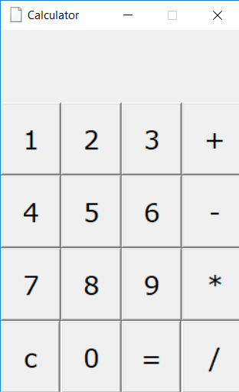

- Addition

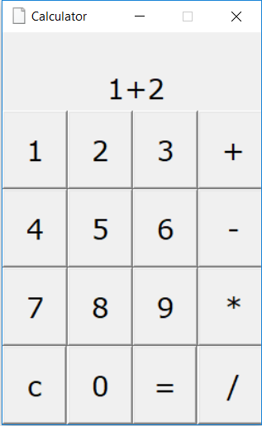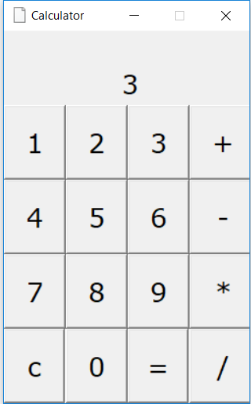
- Subtraction

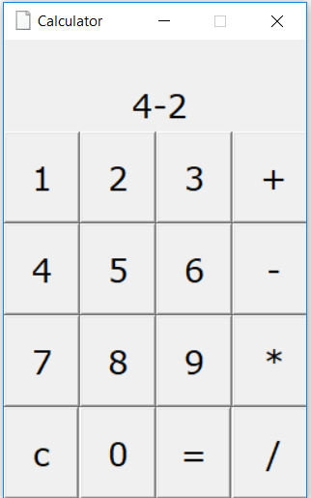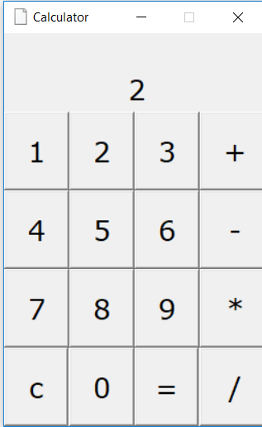

- Multiplication

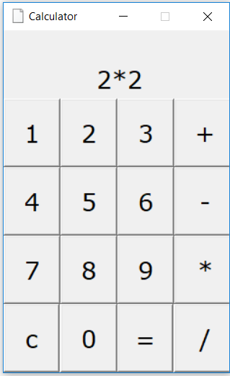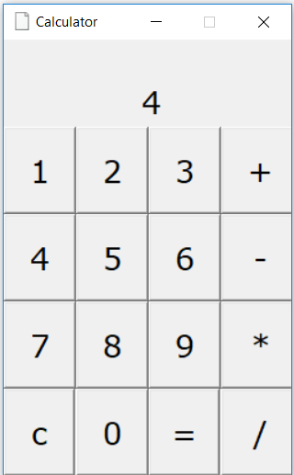

- Division

- Defined

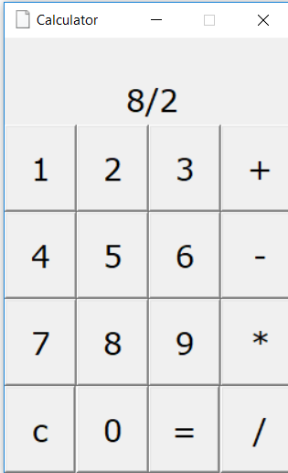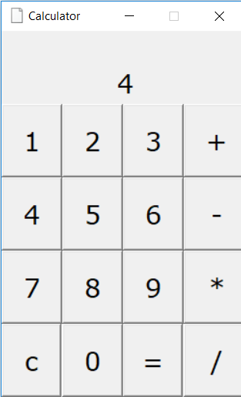

- Undefined

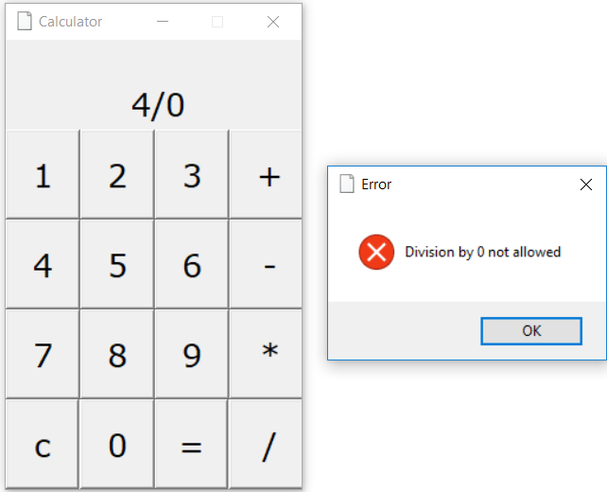
BIBLOGRAPHY

- Computer Science with python by SUMITA ARORA

